EMP study needs

- I cannot recreate 24 hour urines collection with 8 hour bins (of note, 4 hour bins are used at times in studies). Note that multiple cells need to be merged because the 24 hour urine crosses study days
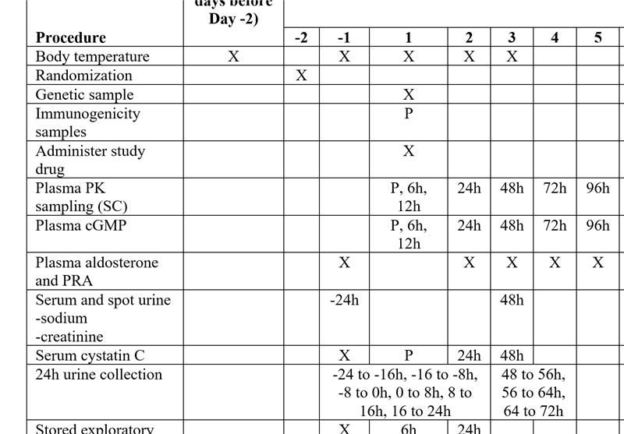

Example 2: J2A-MC-GZGM
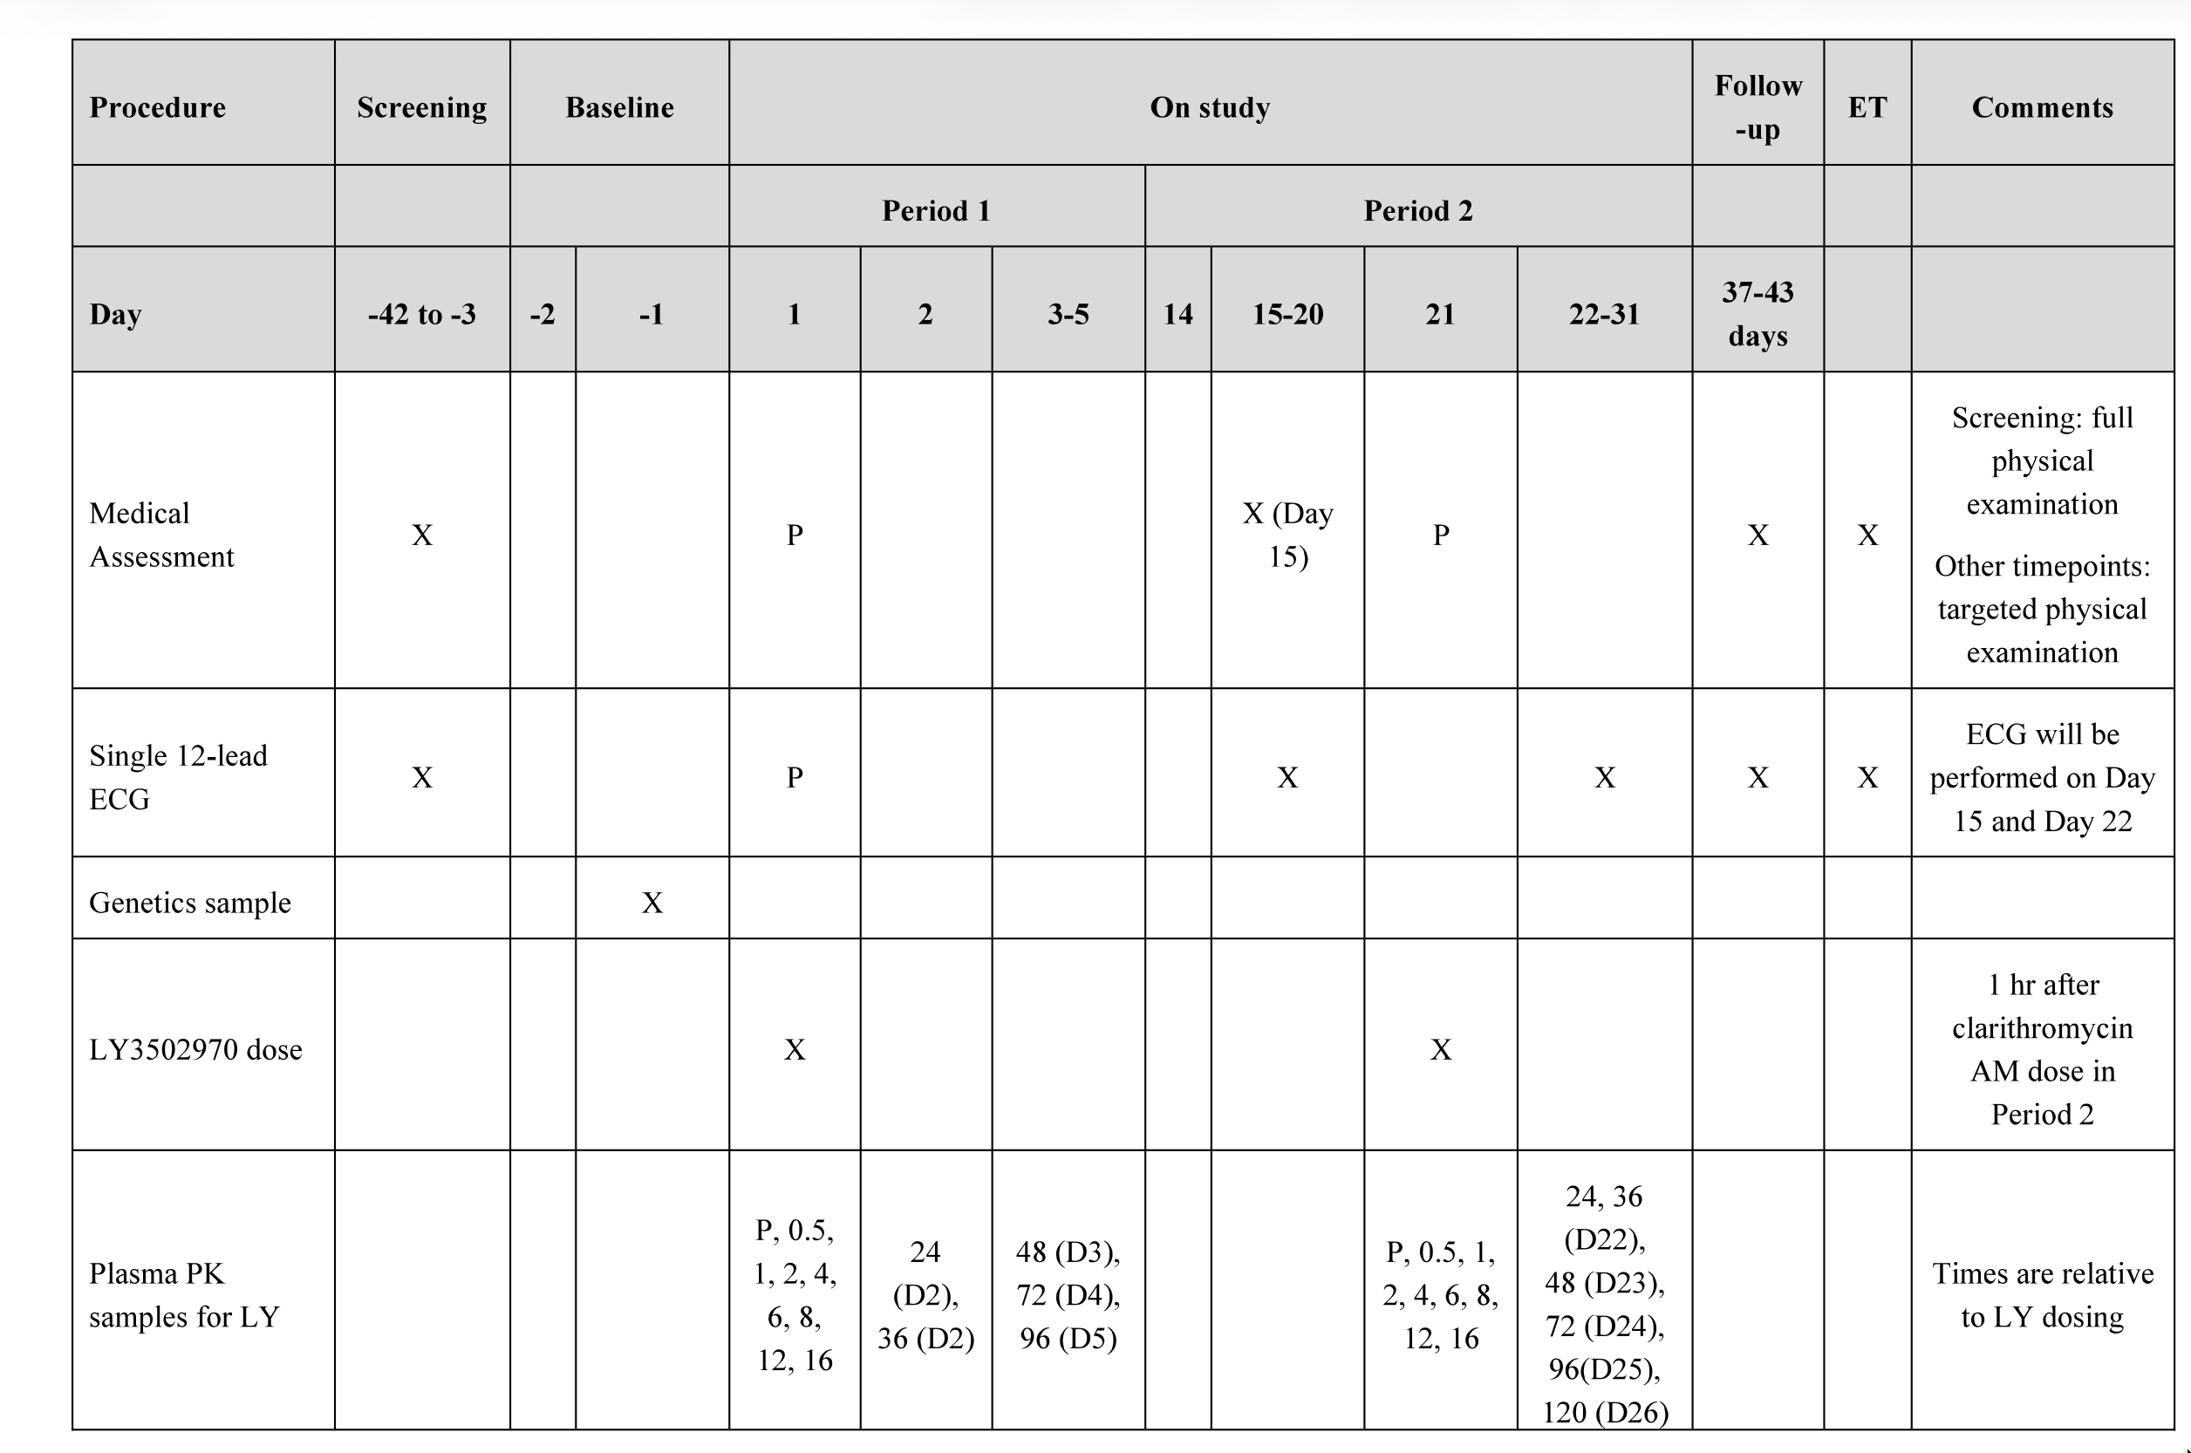

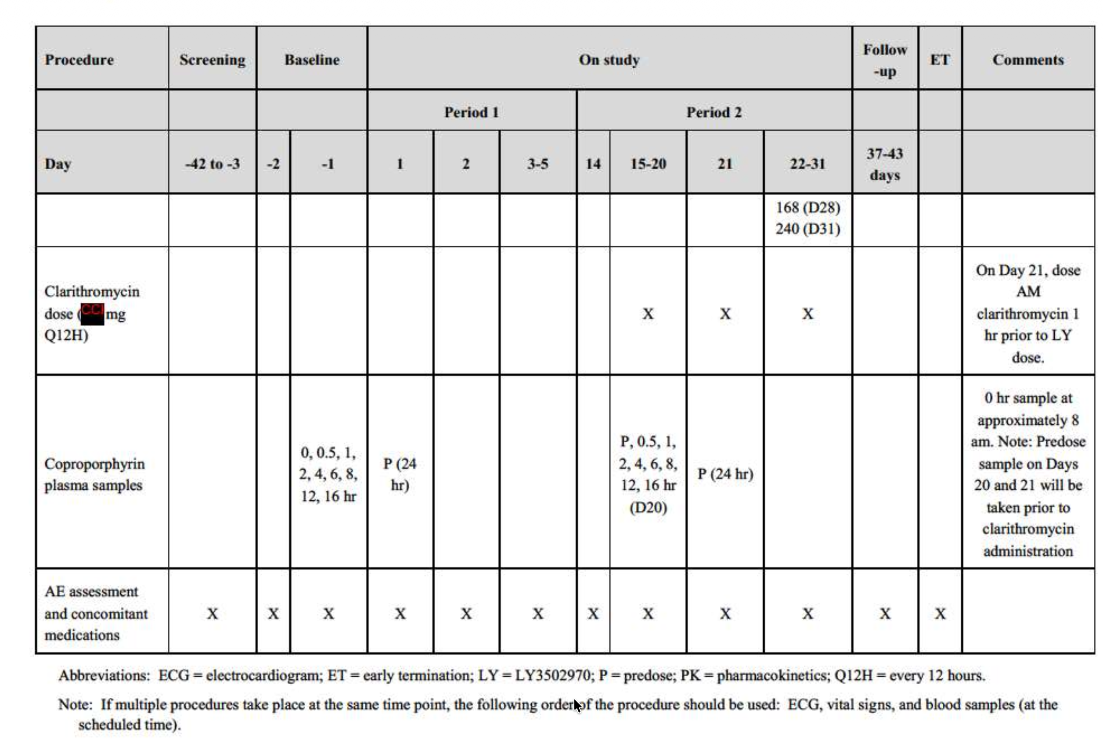

- Heavy usage of footnotes
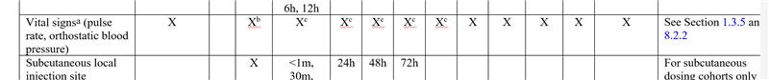
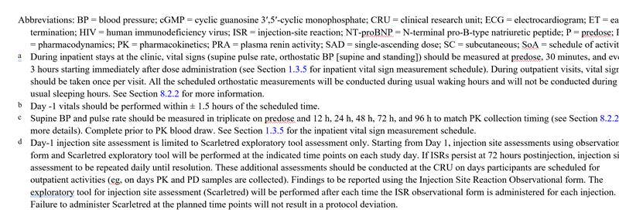
- I need to add time relative to the dose given, I need to be able to enter 24:00 hr, 36:00hr, 48:00 hr, 72:00 hr, etc., 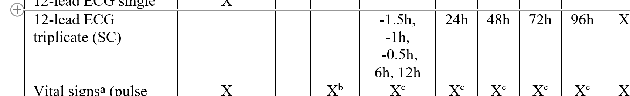

- Also, need a "P" for predose option for each cell.
